**Virtualization**

Virtualization uses software to create an abstraction layer over computer hardware that allows the hardware elements of a single computer—processors, memory, storage and more—to be divided into multiple virtual computers, commonly called virtual machines. Each virtual machine can run a different OS and is independent from the other VMs, even though in reality they are part of the same hardware.

Benefits:

* Cost effective – one hardware can be split into more virtual machines
* Can do everything remotely
* Easier management as you can access them all from one place - online

Drawbacks:

* If the hardware breaks/stops working, all virtual machines/servers will stop working as well.
* Virtualization has its limits
* If the hardware isn’t powerful enough, it can slow down all servers or VMs

IaaS – Infrastructure as a service:

You get access to the applications, Data, Runtime, Middleware, OS

SaaS – Software as a service:

You don’t have any access to anything on the software as it’s a finished product that’s been sold as a service.

Paas – Platform as a service:

You have access to change the application and data.

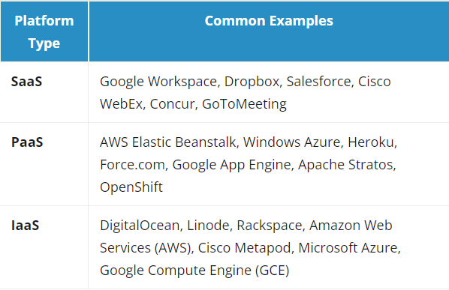

**SaaS:**

Software as a Service, also known as cloud application, services, represents the most utilized option for businesses in the cloud market. SaaS utilizes the internet to deliver applications, which are managed by a third-party vendor, to its users. A majority of SaaS applications run directly through your web browser, which means they do not require any downloads or installations on the client side.

**Saas Delivery:**

Due to its web delivery model, SaaS eliminates the need to have IT staff download and install applications on each individual computer. With SaaS, vendors manage all potential technical issues, such as data, middleware, servers, and storage, resulting in streamlined maintenance and support for the business.

**Advantages:**

SaaS provides numerous advantages to employees and companies by greatly reducing the time and money spent on tedious tasks such as installing, managing, and upgrading software. This frees up plenty of time for technical staff to spend on more pressing matters and issues within the organization.

**Characteristics:**

There are a few ways to help you determine when SaaS is being utilized:

* Managed from a central location
* Hosted on a remote server
* Accessible over the internet
* Users not responsible for hardware or software updates

**Examples:**

* Google Workspace (formerly GSuite)
* Dropbox
* Salesforce
* Cisco WebEx
* SAP Concur
* GoToMeeting

**PaaS:**

Cloud platform services, also known as Platform as a Service (PaaS), provide cloud components to certain software while being used mainly for applications. PaaS delivers a framework for developers that they can build upon and use to create customized applications. All servers, storage, and networking can be managed by the enterprise or a third-party provider while the developers can maintain management of the applications.

**PaaS Delivery:**

The delivery model of PaaS is like SaaS, except instead of delivering the software over the internet, PaaS provides a platform for software creation. This platform is delivered via the web, giving developers the freedom to concentrate on building the software without having to worry about operating systems, software updates, storage, or infrastructure.

**Advantages:**

* Simple, cost-effective development and deployment of apps
* Scalable
* Highly available
* Developers can customize apps without the headache of maintaining the software
* Significant reduction in the amount of coding needed
* Automation of business policy
* Easy migration to the hybrid model

**Characteristics:**

* Builds on virtualization technology, so resources can easily be scaled up or down as your business changes
* Provides a variety of services to assist with the development, testing, and deployment of apps
* Accessible to numerous users via the same development application
* Integrates web services and databases

**Examples:**

* AWS Elastic Beanstalk
* Windows Azure
* Heroku
* Force.com
* Google App Engine
* OpenShift

**IaaS:**

Cloud infrastructure services, known as Infrastructure as a Service (IaaS), are made of highly scalable and automated computer resources. IaaS is fully self-service for accessing and monitoring computers, networking, storage, and other services. IaaS allows businesses to purchase resources on-demand and as-needed instead of having to buy hardware outright.

**Delivery:**

IaaS delivers cloud computing infrastructure, including servers, network, operating systems, and storage, through virtualization technology. These cloud servers are typically provided to the organization through a dashboard or an API, giving IaaS clients complete control over the entire infrastructure. IaaS provides the same technologies and capabilities as a traditional data center without having to physically maintain or manage all of it. IaaS clients can still access their servers and storage directly, but it is all outsourced through a “virtual data center” in the cloud.

**Advantages:**

* The most flexible cloud computing model
* Easy to automate deployment of storage, networking, servers, and processing power
* Hardware purchases can be based on consumption
* Clients retain complete control of their infrastructure
* Resources can be purchased as needed
* Highly scalable

**Characteristics:**

* Resources are available as a service
* Cost varies depending on consumption
* Services are highly scalable
* Multiple users on a single piece of hardware
* Organization retains complete control of the infrastructure
* Dynamic and flexible

Examples:

* DigitalOcean
* Linode
* Rackspace
* Amazon Web Services (AWS)
* Cisco Metacloud
* Microsoft Azure
* Google Compute Engine (GCE)

DaaS – Data as a Service:

Data-as-a-Service (DaaS) providers provide requested data to their consumers via m2m (machine-to-machine) interfaces.

There are 2 forms of DaaS services:

DaaS provider: A company providing requested data to another company via m2m interfaces

Technology provider for DaaS provider: A tech vendor enabling another company to provide its data as a service. DaaS can be provided to other companies or used internally

In both of its forms, DaaS is a cloud data management strategy that offers data accessibility from a variety of sources to drive new applications and digital systems. DaaS removes the need to install and manage software on-premise. It enables organizations to outsource data storage, integration, processing operations and analytics services in the cloud.

**What are its benefits?**

* Agility: DaaS increases the speed to access the necessary data by exposing the data in a flexible but simple way. Users can quickly take action without the need for a comprehensive understanding of where the data is stored or how it is indexed. Agility is the most important benefit of DaaS and it helps decrease time-to-market for DaaS users.
* Financial flexibility: DaaS allows companies to trade-off between investment and operating expenses. Companies can use DaaS to launch services without investing in the systems and personnel to manage their data.
* DaaS reduces the capacity on source systems, cutting costs for licensing, MIPS, and hardware.
* DaaS also helps organizations save maintenance costs. DaaS users don’t need to work on constant testing and maintenance since DaaS vendors keep their tools updated for end-users.
* Data quality: Users access data via the data service. Since data service is the single update point, tracking changes to data is easier which can lead to data quality improvements.
* Cloud flexibility: Cloud offers more flexibility and scalability than on-premises data management alternatives.

Data lakes – a data repository for storing huge amounts of raw data in a single location.